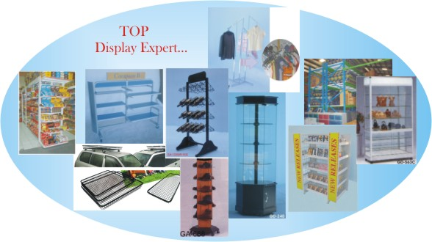

GQSHOP - T&H SHOPFITTERS CORP.
Office: #7 Arganout Hi-way Cor. Efficiency Ave.Subic Bay Industrial Park Phase I
Subic Bay Freeport Zone Philippines
Tel. 047-252-8360 Fax: 047-252-7428
Email: gqshop.rose@gmail.com
Mobile: 09072513168

Brief History:
A company in 1979 was founded to guarantee customer’s satisfaction at a high level; this was named Golden Queen Corporation which was originated in Taiwan. In 1994 we established T&H Shopfitters Corporation in the Philippines and today T&H continuously expands it operation through expansion of buildings & sales & marketing worldwide. We also have Taiwan & China partners.

T&H is currently operating here in the Philippines. Our production space is around 30,000sq meter with 500 staff – we only maintain 300-400people during low season. We also have 6 sub-contractors that provide more people during peak season.

Following are the numbers of key employee’s in the company:

- Design Team = 5
(Corel Draw 12 & CAD system)
- Design Team – TRAINEE = 10 (casual employees)
- Management in-charge = 10
- Supervisors = 11
- Creation Team = 20 (skilled staff who are in-charge in making samples / prototypes)
- Purchasing = 4
- Maintenance & Safety Dept. = 7
- Local Sales & Marketing =4
- Export Sales & Marketing = 10
- Export Sales & Marketing TRAINEE = 20 (casual employees)
- In-house Broker – 2
- Accounting = 2
- Cost Estimator =2

Our factory operates 24hours in 3 shifting. Our Sales & Marketing in-charge are also working 24hours divided into 2 shifting…NO TIME LIMIT!!!

Machines:

- 2 CNC Machine
- 10ft Bending Machine
- 12 Wire & Metal Spot Machine
- 5 Wire & Metal Punching Machine
- 23 Tube, Plate, Wire & Post Punching Machine
- 2 Roller Machine for Metal Channel
- Wood & Metal Cutting Machine
- 3 Wire Cutting Machine
- 2 Tube Cutting Machine
- Buffing Machine
- Drilling Machine
- Oven Powder-Coating Machine
- Etc…

We still have more…

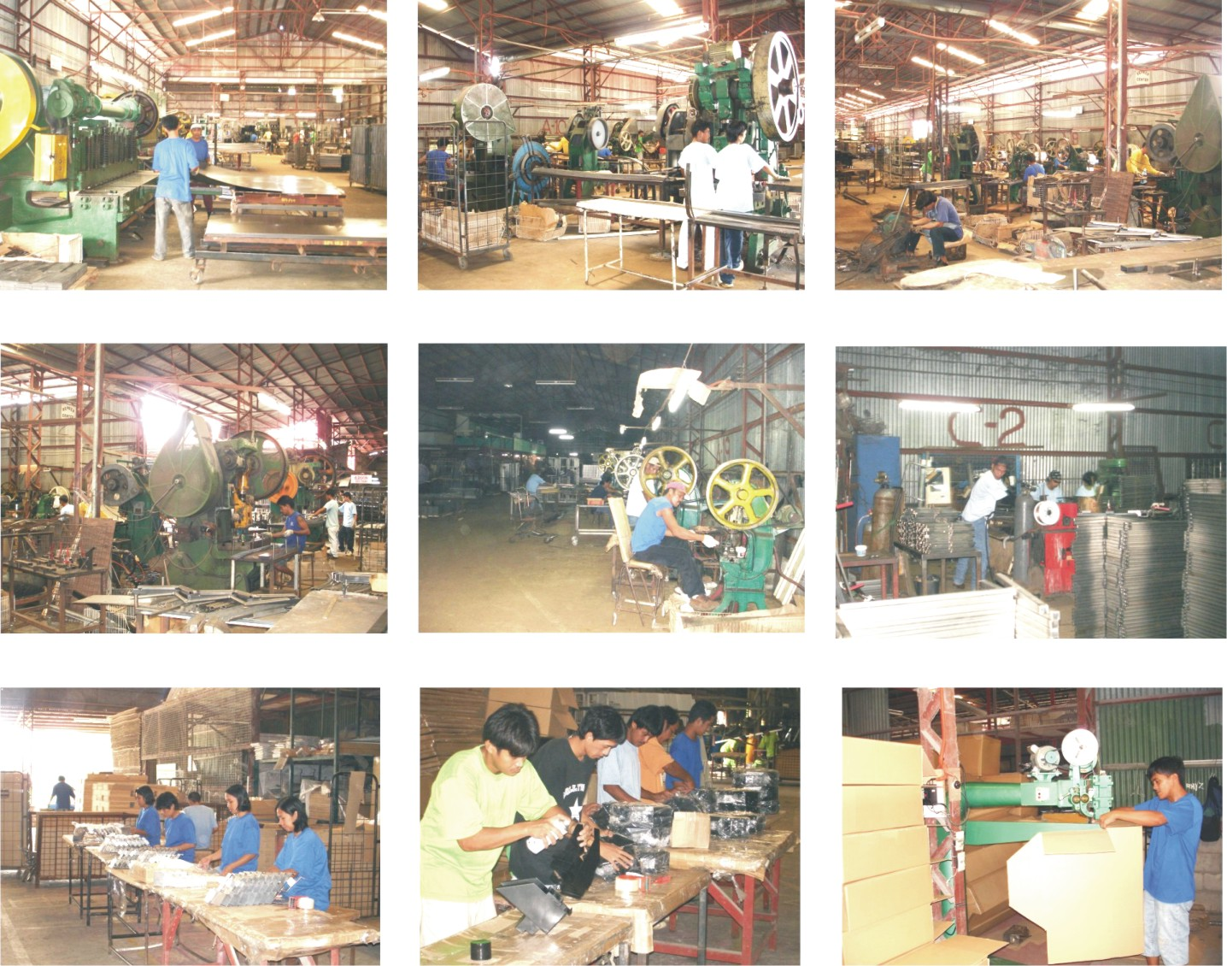

Our products:

- Gondola System
- CD/DVD/Video Racks
- Grid Wall System
- Sales Wagon / Bargain Stand/ Dump Bins
- Hang Rails System ( Wall System)
- Display Racks & Accs.
- Euro Tables ( Fruit & Vegetable Displays)
- Shoe Rack
- Appliances Racks
- Lighting Boxes / Signage’

- Warehouse Rack System
- Slat wall System
- Card / Magazine / Literature Stand
- Slots Standards
- Korean Rack
- Stylish Tables
- Wire Baskets
- Showcases
- Acrylic displays
- Promotional Racks
- Wood Shelving System

Product Finishes:

- Powder-Coated ( in our own factory)
- Chrome Plated ( by sub-contract)
- Zinc Plated ( by sub-contract)
- Silk Screen ( by sub-contract)
- Wood Painting PU - polyurathine (in our factory)
- Matt Natural Anodize (by sub-contract)
- Vinyl ( material we import in Taiwan & China )
- Plastic (material we import in Taiwan & China )

Materials that we are importing:

- PVC – Taiwan
- Special Wire size – Taiwan/ China
- Special Tube size – Taiwan/China
- MDF – Australia/ Malaysia/China
- Vinyl – Taiwan / China
- Nuts / Volts / Wheels – Taiwan/China
- Special Powder colors – Taiwan/China
- Decals / Stickers – Taiwan/China
- Mannequins
- Lights / Motors / Ballast

Countries / States where we are supplying our products:

- Florida, USA
- Los Angeles, California USA
- Mexico, USA
- Texas, USA
- Colorado, USA
- Ohio, USA
- Minnesota, USA
- NY, USA
- Canada
- Atlanta, USA
- Denmark, Europe
- United Kingdom
- Australia
- New Zealand
- Cyprus
- Japan
- Malaysia
- Dubai, UAE
- Riyadh, KSA
- Singapore
- New Zealand
- Naples, Italy
- Germany
- Hongkong

- Kentucky, USA
- Kansas, USA
- Malta – Italy
- Mauritious - India
- Norway
- Sweden
31. Spain

Lead Time Production:

- Samples – 3-5days (for metal & p/coat finish)
- Samples – 7days (for chrome finish/ zinc/ anodized
- Samples – 7-10days (wood finish) it depends on the nature of the item & availability of material that need to use.
- Urgent orders – 20ft or 40ft metal or wire = 3 weeks possible for 2 weeks
- Large orders – about 10containers = 1st two containers in 30days, other’s weekly container 2-3containers per week.

Terms of Payment:

- By wire transfer – 50% deposit upon p.o. receipt + 50% deposit full payment pre-shipped.
- By Letter of Credit – 30% by wire transfer + 70% by L/C at sight.
- T/T after shipment – APPLIED TO OLD BUYERS only.

Shipping:

- We ship samples & urgent items via DHL Express, UPS, & Federal Express & other shipping companies.

- We are working with OOCL, EVERGREEN, APL, & other shipping companies. Mostly are nominated.

- We prepare docs such as INVOICE, PACKING LIST, PACKING DECLARATION, FUMIGATION CERTIFICATE, BILL OF LADING, CERTIFICATE OF ORIGIN, etc…it depends on each customers requirement on docs.

Hope these info’s provided can help you understand what our company can do.

Thanks for the opportunity that you gave.

Respectfully yours,
Rose

Contact Info's:
Roslyn C. Tadeo
Sales Export
T&H SHOPFITTERS CORP.
Philippines
#7 Arganout Hi-way Cor. Efficiency Ave.
Subic Bay Industrial Park Phase I
Subic Bay Freeport Zone
Philippines
tel #: 047-252-8360
fax #: 047-252-7428
Mobile: +639989847868
Email: gqshop.rose@gmail.com
Talk to me online:
Yaho id: Roslyn.tadeo24
skype id: princez_rhose24

